Private sector delivery of quality maternal and newborn health services in [country]: A situational analysis

[date]

Report prepared for the Multi-Stakeholder Workshop by [names]

Table of Contents
1. Introduction 4
2. Research objectives 6
3. Methodology 7
3.1 Project logic model 7
3.2 Study design and setting 8
3.3 Study population and selection 8
3.4 Data collection and analysis 9
3.4.1 Primary data collection and analysis 9
3.4.2 Secondary data collection and analysis 10
3.5 Methodological and data limitations 10
4. Landscape: [National Health Service] and the private sector 12
4.1 Health care system in [country] 12
4.2 Health sector actors in [country] 12
5. Findings 13
5.1 Overview of the private health sector in [country] 13
5.1.1 Private sector engagement in maternal and newborn health services 13
5.1.2 Type, size, and scope of private sector maternal and newborn health services 13
5.1.3 Maternal and newborn health market demand, supply, and segmentation 13
5.2 Characteristics of interview respondents 13
5.3 Emerging themes 14
5.3.1 Available inputs for the private sector 14
5.3.1.1 Key quality policies and strategies for the private sector 14
5.3.1.2 Market conditions (resources) as reported by the private sector 14
5.3.1.3 Market conditions (resources) as reported by the public sector 14
5.3.1.4 Private sector accountability with reporting 14
5.3.2 Private sector processes 14
5.3.3 Private sector outputs 14
5.3.4 Private sector outcomes 15
5.3.5 Available mechanisms to encourage private sector engagement 15
5.3.5.1 Regulatory mechanisms 15
5.3.5.2 Values, ethics, and motivation of the private sector 15
6. Conclusion 16
7. Recommendations 17
7.1 Strengthen Ministry of Health capacity to engage all segments of the private sector (‘enable stakeholders’) 17
7.2 xxx 18
8. References 19
Appendix 1: Glossary 21
Appendix 2: Data sources mapped to the project logic model 22
Appendix 3: Qualitative sampling matrix 23

List of Abbreviations

MNH maternal and newborn health
MOH Ministry of Health
WHO World Health Organization

1. Introduction

The Quality of Care Network, a consortium of 11 countries and their technical partners, aims to halve maternal and newborn deaths and stillbirths in participating health facilities in five years’ time. While the Network’s efforts to achieve this goal have largely focused on strengthening the public health sector, members recognize that private providers are an important source of health care and have a role to play in improving quality care. However, little is known about how to effectively engage and sustain private sector involvement in delivering quality care in low- and middle-income countries. This gap must be addressed if the Network is to achieve its aims.

The private sector plays a key role in delivering sexual and reproductive health services. It provides a substantial proportion of family planning services among women aged 15-49 years in Asia (45%), Latin America and the Caribbean (44%), and sub-Saharan Africa (28%) (Ugaz et al., 2015). One in five births in low- and middle-income countries occurred with care delivered by the private sector (Benova et al., 2015). Data also show that the private sector delivers primary care to all income groups; approximately the same percentage (25%-30%) of the poorest and richest seek care in the private sector in Africa (Montagu and Chakraborty, 2019). Though the private sector’s role is expanding in many countries, the quality of services varies.

Quality of care is fragmented and distributed inequitably between the public and private health sectors (SHOPS Project, 2012). Analyses of health care in both government- and private-sector health facilities have found poor quality across multiple dimensions with little difference between public and private facilities (Basu et al., 2012). Whilst some studies suggest that private providers deliver better service quality than public providers, technical quality amongst the private sector is as poor if not poorer than the public sector (Bhatia and Cleland, 2004, Morgan et al., 2016). A systematic review in lower-middle-income countries revealed that private sector providers (including unlicensed and uncertified providers) were less likely to follow the standards of medical practice, had poorer patient outcomes, and reported lower efficiency than public sector providers (Basu et al., 2012).

Public-private partnerships offer an important opportunity for quality improvement in health care generally and for maternal and newborn health services in particular. Improving quality of care outcomes requires an integrated system of care and productive interactions between the public and private sectors. Poor experience with the health system is believed to have significant impact on patients’ health care seeking behaviours, loss to follow-up, and unnecessary spread of disease.

To accelerate progress to reach the Sustainable Development Goals for ending preventable maternal and newborn deaths, it is critical that both the public and private health sectors invest in increasing coverage of interventions to sustainably deliver quality care at scale. There is a need to understand what can be done to create, nurture, and encourage a vibrant private sector that is fully engaged in improving and sustaining quality of care for mothers and newborns. Towards that end, the World Health Organization has convened an Advisory Group on Governance of the Private Health Sector for Universal Health Coverage that drafted a strategy to strengthen member state capacity to steward a mixed health system that includes specific governance behaviours that will improve public-private interactions, regulations, and quality (WHO, 2020).

2. Research objectives

The purpose of this study is to: (1) explore and identify the mechanisms for engaging the private sector in planning, delivering and demonstrating accountability for quality maternal and newborn health services in [country]; and (2) establish the evidence base on mechanisms that ensure an active and meaningful engagement of the private sector in Network countries for delivering on national plans for quality of care, with a focus on maternal and newborn health.

Specifically, the study aims to:
- Analyse the drivers and determinants of the current engagement of the private sector to deliver quality maternal and newborn health services in [country];
- Identify opportunities for involving the private sector in working within the national health system to deliver quality maternal and newborn health services in [country]; and
- Propose models for effective engagement of the private sector within the national health system for implementing quality maternal and newborn health services in [country].

This report focuses on the first two aims, presenting evidence from key informant interviews on the current engagement of the private sector to deliver quality maternal and newborn health services in [country]. The report concludes with recommendations for how to engage the private sector more effectively in the national health system to deliver quality maternal and newborn health services.

The resulting findings and recommendations will be reviewed and discussed by participants at a multi-stakeholder workshop that will address the study’s third aim.

3. Methodology

This mixed-methods exploratory study sought to establish the evidence base on mechanisms that ensure an active and meaningful engagement of the private sector for delivering on national plans for quality of care with a focus on maternal and newborn health. The research involved conducting a situational analysis comprised of three components: (1) a literature review; (2) a stakeholder assessment; and (3) key informant interviews. The [name of Ethics Committee] approved this research. A glossary of terms used in this report appears in Appendix 1.

3.1 Project logic model

Based on a review of the relevant literature as well as input from colleagues at the World Health Organization and a global advisory working group, we used a logic model (Figure 1) to guide the project. The model depicts key components of the private sector’s involvement in delivering quality maternal and newborn health services within the national health system. It was adapted from the evaluation framework for the scale-up for maternal and child survival (Bryce et al., 2011). At the top and bottom of this model, we include the domains under which different components operate, and we recognize that equity and contextual factors (e.g., political, technological, economic) may affect the progress of the above pathways.

Figure 1. Project logic model

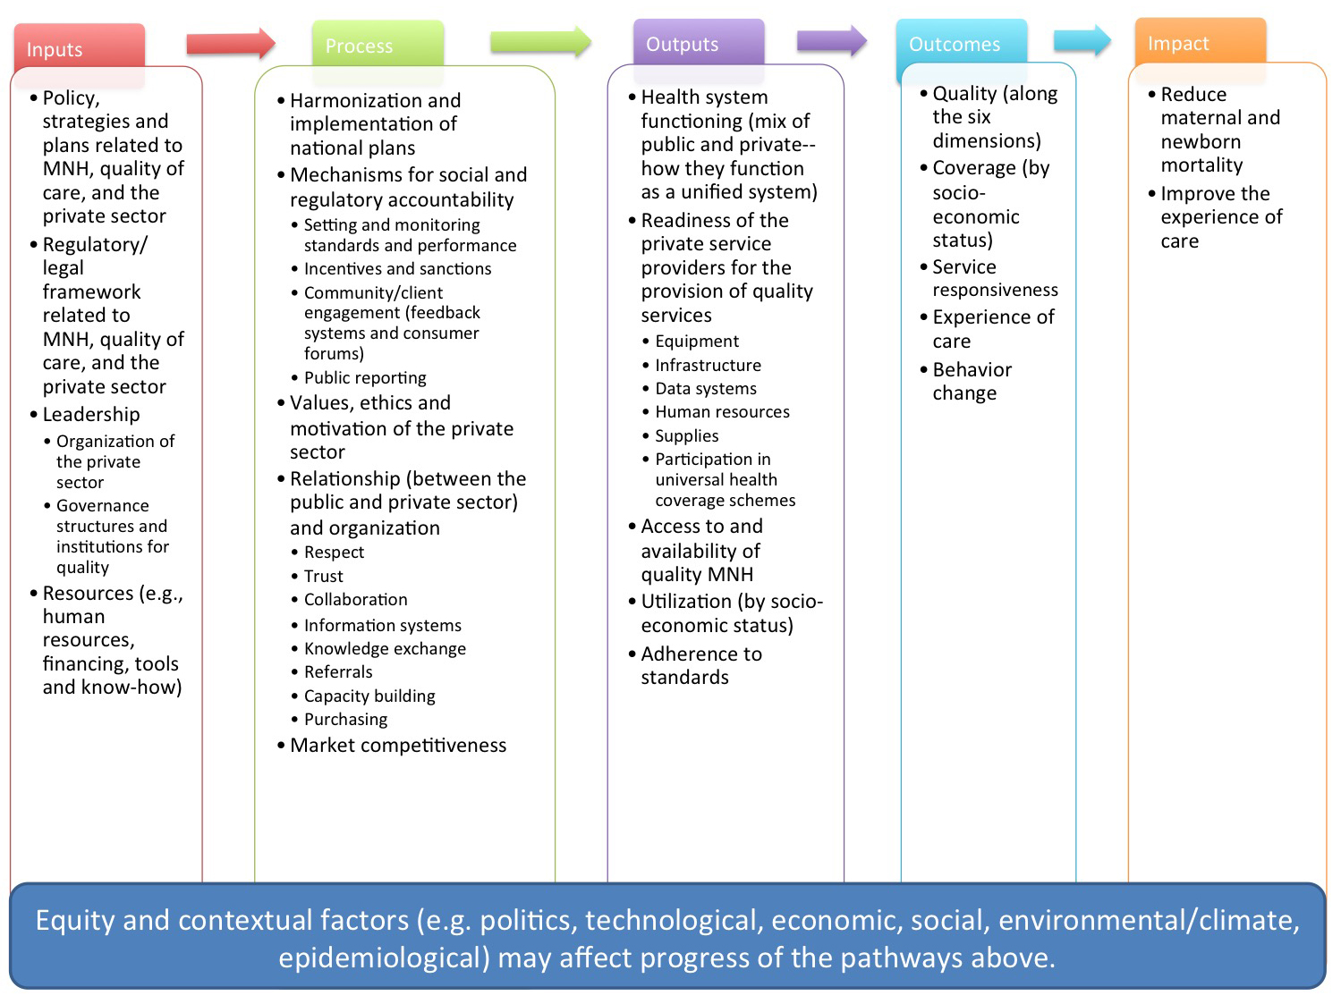

3.2 Study design and setting

We collected and analysed both primary and secondary data. Secondary data and grey literature (e.g., policies, facility-based assessments, reports) provided background context on the private sector (Appendix 2). Key informant interviews produced primary data on inputs, processes, and outputs related to the private sector’s engagement in delivering quality care for maternal and newborn health as part of [country]’s national health system (Appendix 2). Key informants were identified by a stakeholder assessment and input from a national technical working group comprised of representatives from xxx.

[Final number] interview respondents from the public (n=xx) and private (n=xx) sectors discussed private sector engagement and delivery of maternal and newborn health services. We targeted key informants and stakeholders from xxx.

3.3 Study population and selection

For the purpose of this study, we defined the private sector as xxx. However, the project scope focused on formal private sector service delivery of quality maternal and newborn health care. For this reason, we sampled a larger proportion of individuals involved in service delivery than in policy/administration or regulation. Suppliers, research and training institutions, and traditional and alternative medicine providers were excluded.

Individuals were deemed eligible and invited to participate in the key informant interviews if they:
- had experience in and knowledge of service delivery of quality of care and/or maternal and newborn health in [country];
- were currently working in the public health sector and/or the private formal health sector in [country]; and
- had been working in their current role for at least two years.

We selected interview respondents based on a stakeholder assessment for [country] and input from the national technical working group. The stakeholder assessment: (1) identified all the stakeholders in the space and assessed their influence, positions, and interests; and (2) explored stakeholders’ responses with respect to policies, strategies, regulations, incentives, private investments, etc. Following this step and the prioritization of stakeholders with the technical working group, eligible interview respondents in [country] were selected purposively using a sampling matrix (Appendix 3) to capture a range of viewpoints and experiences with private sector service delivery of quality maternal and newborn health.

Using a non-probabilistic stratified purposive sampling approach and important characteristics put forth in the literature, the final sample size was influenced by the sampling matrix (Appendix 3). We identified respondents who had policy/administration, service delivery, and regulation roles within the public or private sector, at the national, regional, district and facility level. Informants were selected based on these characteristics until saturation occurred.

3.4 Data collection and analysis

Both data (i.e. primary and secondary) were collected at the same time and subsequently integrated to facilitate an appropriate interpretation of the overall results presented in this report. We anticipate more robust results from mixing methods rather than using the two approaches separately.

3.4.1 Primary data collection and analysis

Trained interviewers conducted the interviews using one of six semi-structured interview guides tailored to the three roles in the sampling matrix (Appendix 3): policy/administration, service delivery, and regulation. Each of these roles has one guide for private sector respondents and one guide for public sector respondents. Interview guides were developed based on the logic model framework (Figure 1) and an assessment of existing tools (Barnes et al., 2008, Brunner et al., 2018, GFF, 2016, Makinen et al., 2011, O’Hanlon et al., 2016, SHOPS PLUS, 2014, SHOPS Plus, 2019, SHOPS Project, 2016, Wadge et al., 2017).

The semi-structured interview guides, piloted prior to the study’s commencement, included open-ended questions that covered the following topics: policies, plans and strategies related to quality maternal and newborn health; regulatory/legal framework; accountability; leadership; availability of resources; values, ethics and motivation of the private sector; market competitiveness; relationships between the public and private sectors; improved health systems functioning; improved readiness of private sector service providers for the provision of quality maternal and newborn health; and improved access to and availability of quality maternal and newborn health.

Audio-recorded interview data were transcribed verbatim and critically examined for accuracy and representation of the response of the respondent. Data extraction templates were used to assist the organization and retrieval of themes from the data. Qualitative data from the key informant interviews were analysed using the content and thematic analysis technique and organized around the logic model. The quotations presented in this report are not verbatim and have been lightly edited for conventions of English grammar and readability.

3.4.2 Secondary data collection and analysis

For the literature review, secondary qualitative and quantitative data were collected from grey and published literature on the private sector. A secondary analysis of data gathered by this review (Appendix 2) provides descriptive statistics of key features of the private health sector in [country], such as the size, scope, distribution, and quality of maternal and newborn health services delivered.

Given the size of the complete literature review, this report pulls in select content and findings.

3.5 Methodological and data limitations

There are inherent limitations to the qualitative primary data collection inputs used for this research that need to be acknowledged and kept in mind when interpreting the findings. Key informant interviews are frequently used in social science research in order to gather information and identify key drivers/variables/information prior to the design and formulation of a relevant policy or intervention. Although useful, it is important to understand where biases can be introduced so as to cautiously interpret, frame, and validate the findings:

- Selection bias: Findings may be biased if informants are not carefully selected. For example, the respondents selected may not be the right individuals within the organisation and/or may have inherent biases (political, etc.) that influence their responses.
- Interviewer bias: Interviewer training, skill, and bias may sometimes provide bias, as the interviewer may unconsciously devise questions so as to secure/confirm certain views that s/he holds. On the other hand, interviewer presence stimulates respondents in terms of providing more detailed responses. Additionally, it is possible that the interviewer may inhibit the respondent from providing unencumbered responses because there is no anonymity; interviewers can attempt to overcome this challenge by using strategies like developing rapport with the respondent and choosing an appropriate location for the interview are crucial.
- Validity of results may sometimes be difficult to prove overall.

Acknowledging the limitations above, the research team has tried to mitigate these biases through: (1) careful selection of respondents, (2) use of experienced interviewers, (3) reviews of transcriptions/analyses by multiple individuals, (4) and triangulation of the interview findings with findings from the secondary literature review.

Furthermore, it is important to note that the findings presented in this report are intended as initial inputs to a subsequent multi-stakeholder dialogue that will gather relevant stakeholders to further “validate” these findings before designing the final policy recommendations/interventions resulting from this research.

4. Landscape: [National Health Service] and the private sector

4.1 Health care system in [country]

4.2 Health sector actors in [country]

Figure 2. Key public and private sector stakeholders in [country]’s health sector

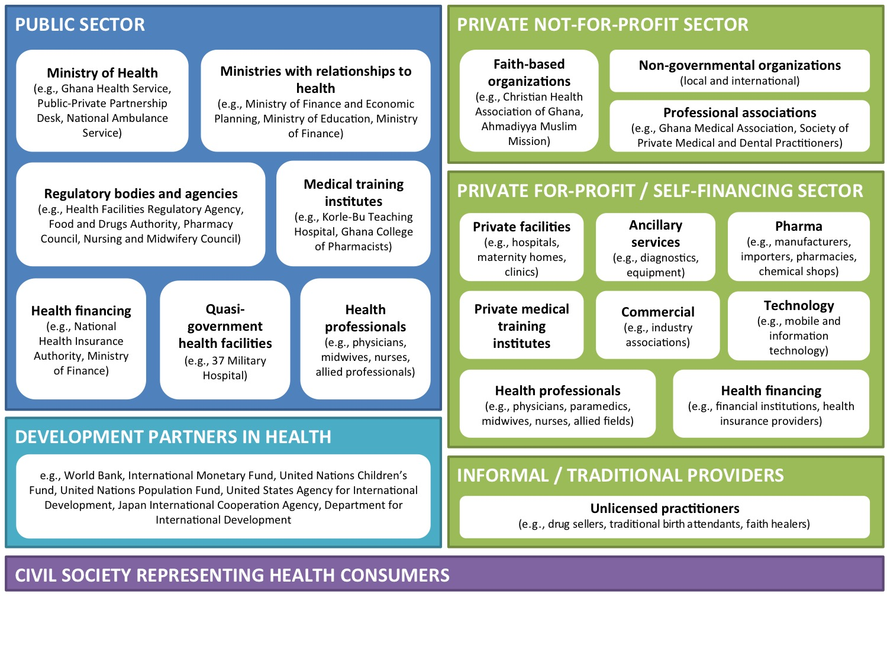

5. Findings

This study documented the implementation experiences and lessons learned from the private sector and its interaction with the public sector for delivering quality maternal and newborn health services in [country]. First, we present an overview of the health system to orient readers to the private health sector in [country] and private sector engagement in maternal and newborn health services. Then, we present characteristics of the in-depth interview respondents included in our sample. Finally, we present themes that emerged from the primary in-depth interview data and the secondary data analysis. These findings are organized thematically around the project logic model (see Figure 1).

5.1 Overview of the private health sector in [country]

This overview provides descriptive statistics on key features of the private health sector in [country], such as the scale and quality of services delivered, and is based on findings from an analysis of secondary data conducted as part of the project literature review (Appendix 2).

5.1.1 Private sector engagement in maternal and newborn health services

5.1.2 Type, size, and scope of private sector maternal and newborn health services

5.1.3 Maternal and newborn health market demand, supply, and segmentation

5.2 Characteristics of interview respondents

Table 1: Characteristics of interview respondents

Variables | Public N (%) | Private (N, %) | Total (N, %)
Roles of respondents
Policy
Regulation
Service delivery
Total
Geographical distribution of respondents
Rural
Urban
Total
Sex*
Male
Female
Total
Interview method
Face-to-face
Phone
Zoom
Total

5.3 Emerging themes

5.3.1 Available inputs for the private sector

This section focuses on findings related to the first pillar of our logic model: inputs (see Figure 1).

5.3.1.1 Key quality policies and strategies for the private sector

5.3.1.2 Market conditions (resources) as reported by the private sector

… I won’t say it is an unfair comment, but I think they are entitled to do that because of the historical antecedent of our current regulatory regime. Like I told you, we used to have a law that looked at only private institutions. And once you have a new order, you have to make sure that you continually train, retrain, and reorient the regulators to understand that now it is everybody and not one. Therefore, the tendency that old habits die-hard may not be something that I can dispute. Apart from the public policy consideration, there are also political considerations. So when you are going to make a decision, what may be in the regulatory body’s best interest is not necessarily the political best interest.
- Respondent who works in one of the Regulatory agencies of the Ministry of Health

5.3.1.3 Market conditions (resources) as reported by the public sector

5.3.1.4 Private sector accountability with reporting

5.3.2 Private sector processes

This section focuses on findings related to the second pillar of our logic model: process (see Figure 1).

5.3.3 Private sector outputs

This section focuses on findings related to the third pillar of our logic model: outputs (see Figure 1).

5.3.4 Private sector outcomes

This section focuses on findings related to the fourth pillar of our logic model: outcomes (see Figure 1).

5.3.5 Available mechanisms to encourage private sector engagement

This section focuses on available mechanisms for engaging the private sector through existing inputs and processes (see Figure 1).

5.3.5.1 Regulatory mechanisms

5.3.5.2 Values, ethics, and motivation of the private sector

6. Conclusion

Using primary and secondary data, this report examined the drivers and determinants of the current engagement of the private sector to deliver quality maternal and newborn health services in [country] through the lens of the project logic model: inputs, processes, outputs, outcomes, and impact of formal private sector service delivery on quality maternal and newborn health services. Primary data also revealed potential mechanisms to encourage private sector engagement, such as [xxx]. Based on these findings, there are numerous opportunities for involving the private sector in working within the national health system to deliver quality maternal and newborn health services in [country] (see ‘Recommendations’ below).

Before addressing the initial recommendations, it is important to recognize that [country] has already achieved a number of successes related to collaboration with the private health sector…

Yet, [country] also has several barriers to private sector engagement that require attention, particularly in the enabling environment. These barriers include (i) xxx, (ii) xxx, (iii) xxx, (iv) xxx, and (v) xxx.

These challenges are further complicated by ...

[Include benchmarking with regional and global experiences to ensure that the team does not miss relevant opportunities and lessons learned from other countries’ experiences in private sector engagement]

[country] is on the path to improve quality of maternal and newborn health services. By building on its foundation of [xxx (public-private collaboration, etc.)] and implementing the recommendations proposed here, [country] can better engage the private sector and improve the quality of maternal and newborn health amongst self-financing providers. Indeed, many of these recommendations are based on successful experiences and examples from regional and lower- and middle-income countries (GFF, 2016, SHOPS Plus, 2019, Ministry of Health - Ethiopia et al., 2019) as well as the World Health Organization’s draft strategy on private sector engagement (WHO, 2020). When the public and private health sectors come together to commit to improving the quality of maternal and newborn health services, improvements in health are both feasible and possible.

7. Recommendations

Based on the findings from key informants in [country], clear opportunities exist to strengthen private sector engagement for better delivery of quality maternal and newborn health services. These recommendations align with the World Health Organization’s strategy to strengthen governance of mixed health sectors and to engage private sector providers to partner with governments to achieve universal health coverage (see Figure 9) (WHO, 2020). The proposed recommendations align with the ‘enable stakeholders,’ ‘align structures,’ ‘build understanding,’ and ‘foster relations’ governance behaviours.

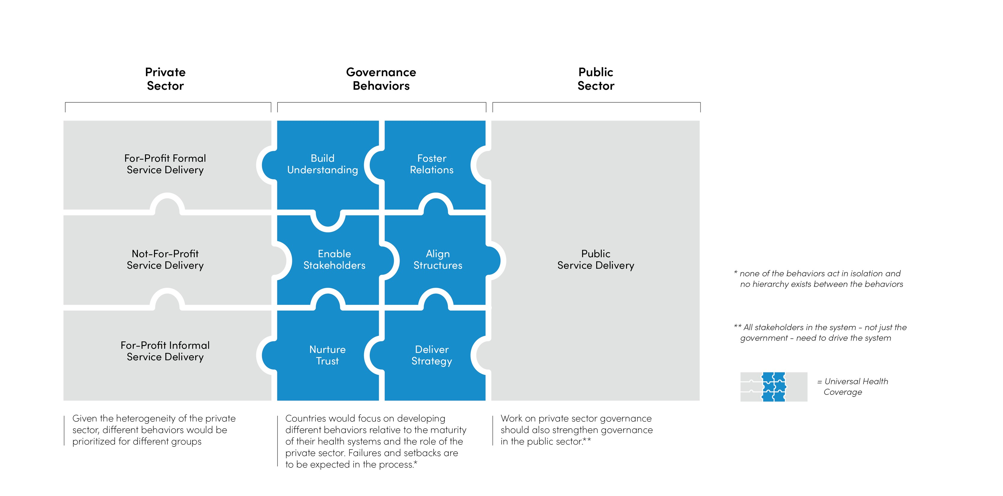
Figure 9. Six governance behaviours to strengthen private sector engagement

These initial recommendations, while broad, will be refined at the forthcoming multi-stakeholder workshop by stakeholders from the public and private sectors. Based on this initial report, participants will identify and prioritize key challenges and actionable issues to address during the workshop. These challenges will then be detailed out in specific problem statements for which concrete recommendations can be made. Then, participants will develop recommendations addressing these key challenges and actionable next steps. Finally, participants will finalize a plan for implementation of the recommendations along with partnership ideas.

7.1 Strengthen Ministry of Health capacity to engage all segments of the private sector (‘enable stakeholders’)

While the Ministry of Health has a Private Sector Unit (recently renamed “Resource Mobilization”), this unit is currently under resourced and under capacitated. The unit lacks the required resources and capacity to enact a clear dialogue platform by which to formally and systemically engage and interact with all segments of the private health sector. Recommended actions and activities may include the following:
- Expand the mandate of the Private Sector Unit to become a dedicated department with a clear mandate and resources for staff and implementation; or make the existing Unit more prominent
- Raise awareness among Ministry of Health leadership both nationally and regionally on successful models to engage the private sector to improve quality of maternal and newborn health services
- Develop staff capacity within key ministry departments in skills needed to engage and implement private sector models
- Develop mechanisms for ensuring that the private sector benefits from health system strengthening interventions for improving quality
- Ministry of Health should convene private sector (both self-financing and not-for-profit) groups key to maternal and newborn health in order to develop a partnership strategy

7.2 xxx

8. References

BARNES, J., CHANDANI, T. & FEELEY, R. 2008. Nigeria Private Sector Health Assessment. Bethesda, MD, USA: Private Sector Partnerships-One project, Abt Associates Inc.

BASU, S., ANDREWS, J., KISHORE, S., PANJABI, R. & STUCKLER, D. 2012. Comparative Performance of Private and Public Healthcare Systems in Low- and Middle-Income Countries: A Systematic Review. Plos Medicine, 9.

BENOVA, L., MACLEOD, D., FOOTMAN, K., CAVALLARO, F., LYNCH, C. A. & CAMPBELL, O. M. R. 2015. Role of the private sector in childbirth care: cross-sectional survey evidence from 57 low- and middle-income countries using Demographic and Health Surveys. Tropical Medicine & International Health, 20, 1657-1673.

BHATIA, J. & CLELAND, J. 2004. Health care of female outpatients in south-central India: comparing public and private sector provision. Health Policy Plan, 19, 402-9.

BRUNNER, B., BACZEWSKI, K., MANGONE, E., HOLTZ, J., COMBET, V., ESTEVEZ, I. & DAVIS, B. 2018. Madagascar Private Health Sector Assessment. Rockville, MD, USA: Sustaining Health Outcomes through the Private Sector Plus Project. Abt Associates Inc.

BRYCE, J., VICTORA, C. G., BOERMA, T., PETERS, D. H. & BLACK, R. E. 2011. Evaluating the scale-up for maternal and child survival: a common framework. Int Health, 3, 139-46.
GFF 2016. Private sector contributions to maternal and reproductive health: Excerpt from the 2016 Uganda private sector health assessment. Global Financing Facility.

GFF 2019. GFF country profile on private sector role in RMNACH. In: GLOBAL FINANCING FACILITY (ed.). (unpublished internal data).

MAKINEN, M., SEALY, S., BITRÁN, R. A., ADJEI, S. & MUÑOZ, R. 2011. Private Health Sector Assessment in Ghana. World Bank Working Paper, No. 210. Washington, DC, USA: World Bank.

MINISTRY OF HEALTH - ETHIOPIA, GLOBAL FINANCING FACILITY & WORLD BANK 2019. Ethiopia Health Private Sector Assessment. Addis.

MONTAGU, D. & CHAKRABORTY, N. 2019. Private Sector Utilization: Insights from Standard Survey Data. Geneva: World Health Organization.

MORGAN, R., ENSOR, T. & WATERS, H. 2016. Performance of private sector health care: implications for universal health coverage. The Lancet, 388, 606-612.

O’HANLON, B., NAKYANZI, A., MUSEMBI, V., BUSULWA, I., HUSBAND, R., OKUMU, R., ZIKUSOOKA, F., BATUSA, J., KIRAGGA, D., BYAKIKA, S., MUSILA, T., KEBIRUNGI, S., KYAMBADDE, A. & KANNEGANTI, S. 2016. Exploring partnership opportunities to achieve universal health access: 2016 Uganda private sector assessment in health. Cardno Emerging Markets USA, Ltd.

SHOPS PLUS. 2014. Assessment to Action: Stakeholder Questions [Online]. Available: https://assessment-action.net/stakeholder-questions/ [Accessed 5 March 2020].

SHOPS PLUS 2019. Democratic Republic of the Congo Private Health Sector Assessment. Rockville, MD, USA: Sustaining Health Outcomes through the Private Sector Plus Project, Abt Associates.

SHOPS PROJECT 2012. Nigeria Private Health Sector Assessment. Bethesda, MD, USA: Strengthening Health Outcomes through the Private Sector Project, Abt Associates.

SHOPS PROJECT 2016. Strengthening Health Outcomes through the Private Sector Project: Final Report 2009–2016. Bethesda, MD, USA: SHOPS Project, Abt Associates Inc.

UGAZ, J. I., CHATTERJI, M., GRIBBLE, J. N. & MITCHELL, S. 2015. Regional trends in the use of short-acting and long-acting contraception accessed through the private and public sectors. International Journal of Gynecology & Obstetrics, 130, E3-E7.

WADGE, H., ROY, R., SRIPATHY, A., PRIME, M., CARTER, A., FONTANA, G., MARTI, J. & CHALKIDOU, K. 2017. Evaluating the impact of private providers on health and health systems. London: Imperial College London.

WHO 2020. Strategy Report: Engaging the private health service delivery sector through governance in mixed health systems. Geneva: World Health Organization.

Appendix 1: Glossary

This glossary is intended to assist readers in understanding commonly used terms and concepts when reading, interpreting, and evaluating this research.

Bias – a loss of balance and accuracy in the use of research methods. Bias can appear in research via the sampling frame, random sampling, or non-response. It can also occur at other stages in research, such as while interviewing, in the design of questions, or in the way data are analysed and presented.
Framework – the structure and support that may be used as both the launching point and the on-going guidelines for investigating a research problem.
KII (Key Informant Interviews) – KIIs involve interviewing people who have particularly informed perspectives on an aspect of the program being evaluated. Key informant interviews are "qualitative, in-depth interviews of 15 to 35 people selected for their first-hand knowledge about a topic of interest.
Mixed-methods – This research approach uses two or more methods from both the quantitative and qualitative research categories. It is also referred to as blended methods, combined methods, or methodological triangulation.
Private (Health) Sector – This refers to all non-governmental health actors: self-financing, faith-based organisations, and non-governmental organizations in the Ghana health sector landscape.
Private Sector Engagement (PSE) – Public-private engagement in health is the mutually beneficial collaboration between public and private health sector entities for the purpose of advancing public health goals and achieving sustainable health outcomes.

Appendix 2: Data sources mapped to the project logic model

Inputs
Topic | Interviews | Literature Review
Policy, strategies and plans related to maternal and newborn health, quality of care, and the private sector | x | x
Regulatory/legal framework related to maternal and newborn health, quality of care, and the private sector | x | x
Leadership, including organization of the private sector and governance structures and institutions for quality | x
Resources for the private sector | x
Process
Topic | Interviews | Literature Review
Harmonization and implementation of national plans | x | x
Mechanisms for social and regulatory accountability | x
Values, ethics and motivation of the private sector | x
Relationship between the public and private sector and its organization | x
Market competitiveness | x
Outputs
Topic | Interviews | Literature Review
Improved health system functioning | x
Improved readiness of the private service providers for the provision of quality maternal and newborn health services |  | x
Improved access to and availability of quality maternal and newborn health services |  | x*
Improved utilization |  | x*
Adherence to standards |  | x
Outcomes
Topic | Interviews | Literature Review
Quality |  | x*
Coverage |  | x*
Equity |  | x*
Service responsiveness |  | x*
Experience of care |  | x
Behavior change |  | x
Impact
Topic | Interviews | Literature Review
Reduce maternal and newborn mortality |  | x*
Improve the experience of care |  | x

* including secondary quantitative data

Appendix 3: Qualitative sampling matrix

Health Sector | Role | Level
Public Health Sector | Policy / administration | National
 |  | Sub-National
 | Service delivery | National
 |  | Sub-National
 |  | Facility (Manager/Director)
 | Regulation | National
 |  | Sub-National
Private Health Sector | Policy / administration | National
 |  | Sub-National
 | Service delivery | National
 |  | Sub-National
 |  | Facility (Manager/Director)
 |  | Facility (Service Provider)
 | Regulation | National and/or sub-national

