Engaging the private sector in delivering quality maternal and newborn health services in [country]: A case study

Authors

Word count
xxx words

Keywords
private health sector; maternal health; newborn health; quality of care

Abbreviations
WHO World Health Organization

Abstract

Introduction

Methods

Results

Conclusion

SUMMARY BOX

What is already known?

What are the new findings?

What do the new findings imply?

Introduction

Overview of the private health sector in [country]

Study purpose and aims

Methods

Study design and setting

Sampling and eligibility criteria

Data collection

[include details for primary and secondary data]

Data analysis

[include details for primary and secondary data]

Ethical clearance

Study limitations

Patient and public involvement

Results

Size and scope of private sector delivery of maternal and newborn health services

Figure xx. Key public and private sector stakeholders in [country]’s health sector
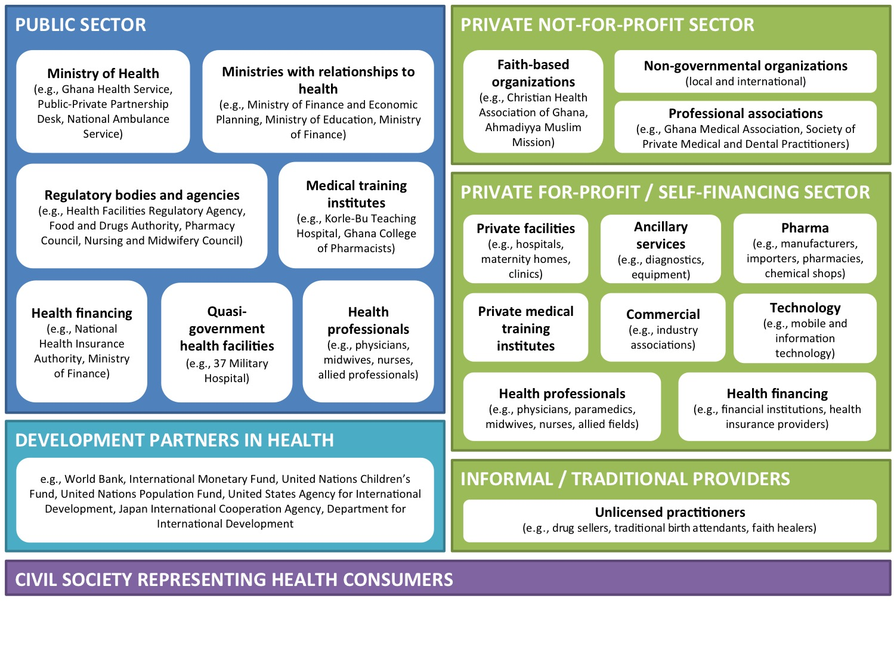

Themes from the situational analysis

Recommendations from the multi-stakeholder workshop

Table xx. Summary of Challenges, Solutions, and Recommendations by Thematic Area

Thematic area 1
Key challenges | Solutions | Recommendations
Key challenge 1  Problem statement(s) | Solution 1  Solution 2 | Recommendation 1  Recommendation 2  Recommendation 3
Key challenge 2  Problem statement(s) | Solution 1 | Recommendation 1  Recommendation 2
Thematic area 2
Key challenges | Solutions | Recommendations
Key challenge 1  Problem statement(s) | Solution 1 | Recommendation 1  Recommendation 2
Key challenge 2  Problem statement(s) | Solution 1  Solution 2 | Recommendation 1  Recommendation 2  Recommendation 3

Discussion

Conclusion

Acknowledgements
We wish to thank…

Competing interests

Funding
This work was supported by MSD for Mothers and the Maternal, Newborn, Child and Adolescent Health and Ageing Department of the World Health Organization. MSD for Mothers had no role in the design and development of the study protocol or the decision to publish.

Contributors

Data availability

References

